# SIEM LAB

# Create VM:

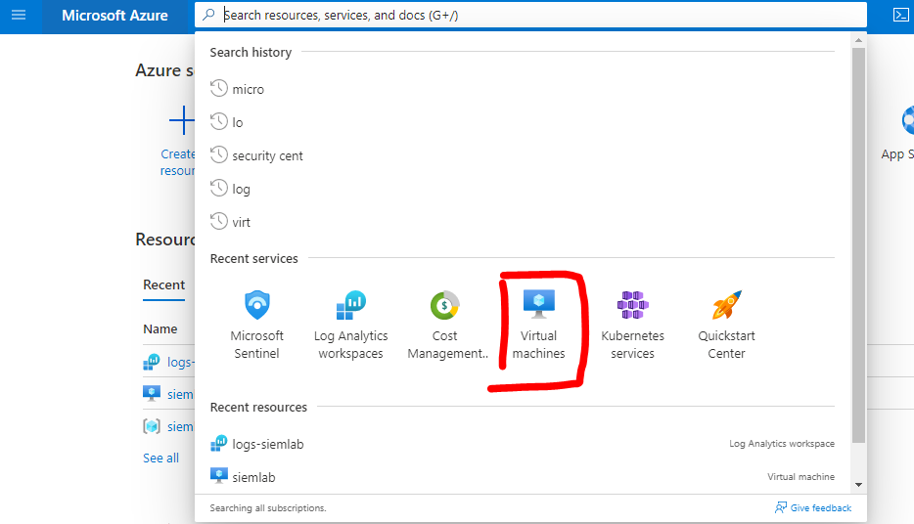

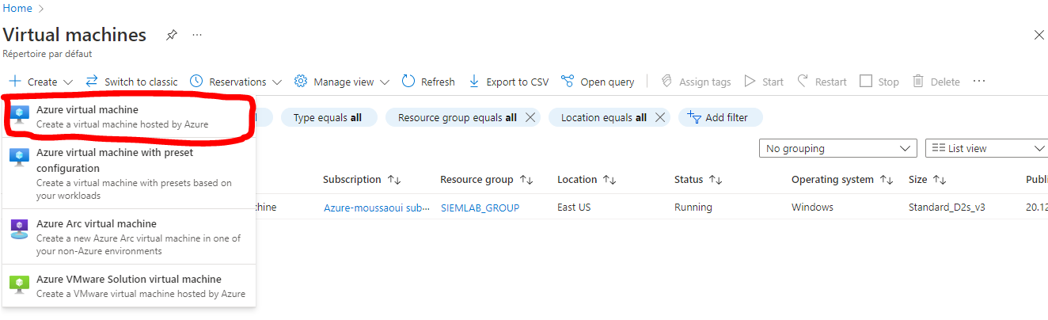

* Created machine

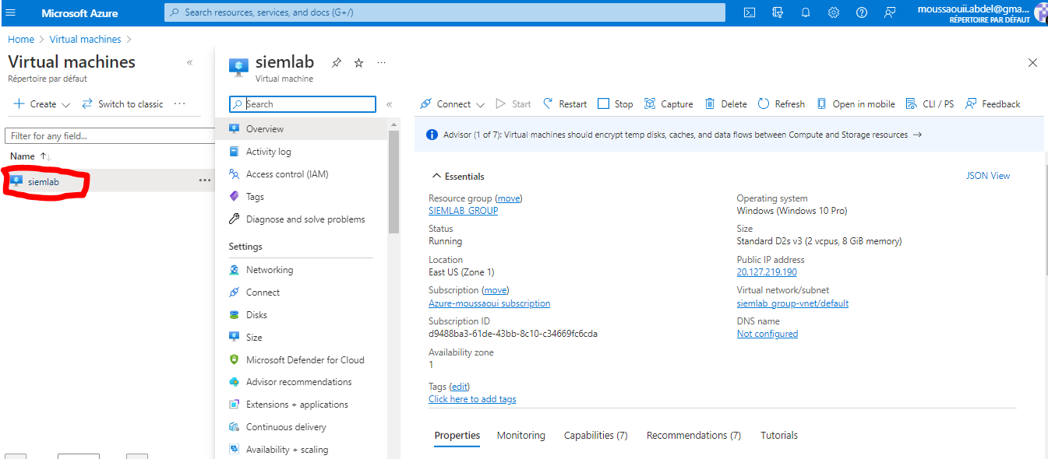

# Create log analytics:

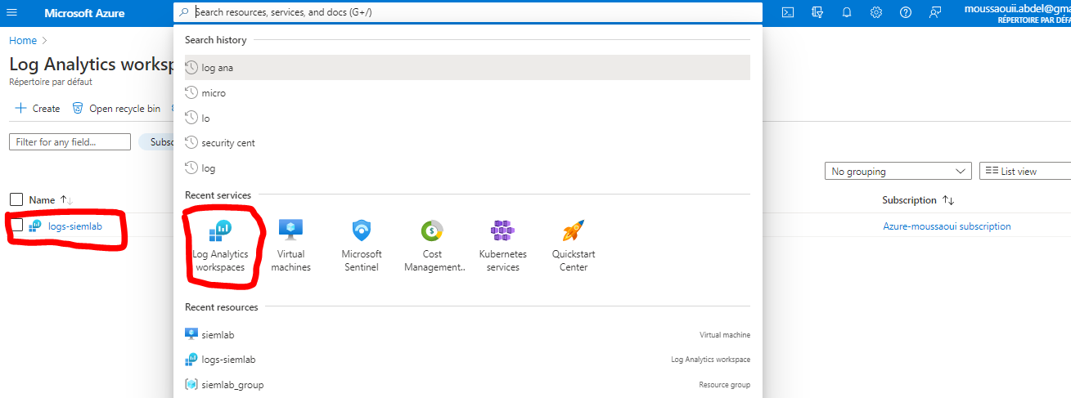

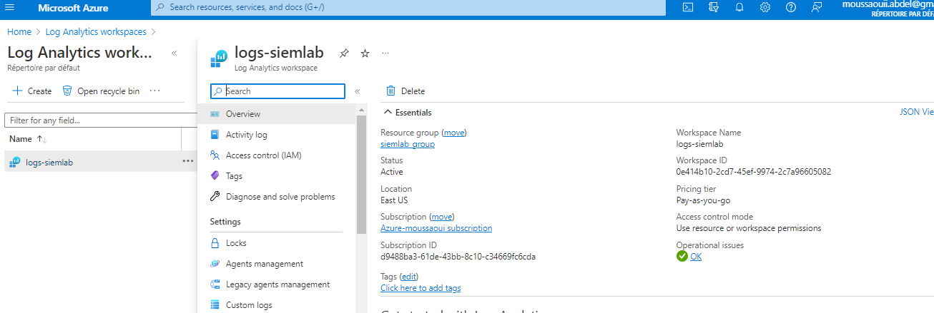

# Enable gathering logs from VM to log analytics:

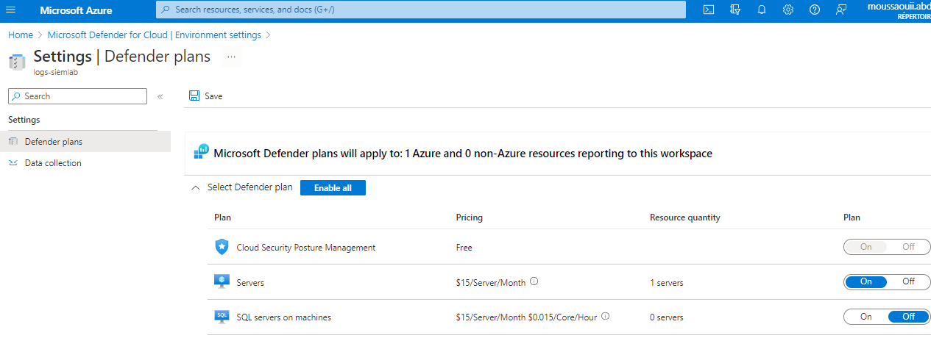

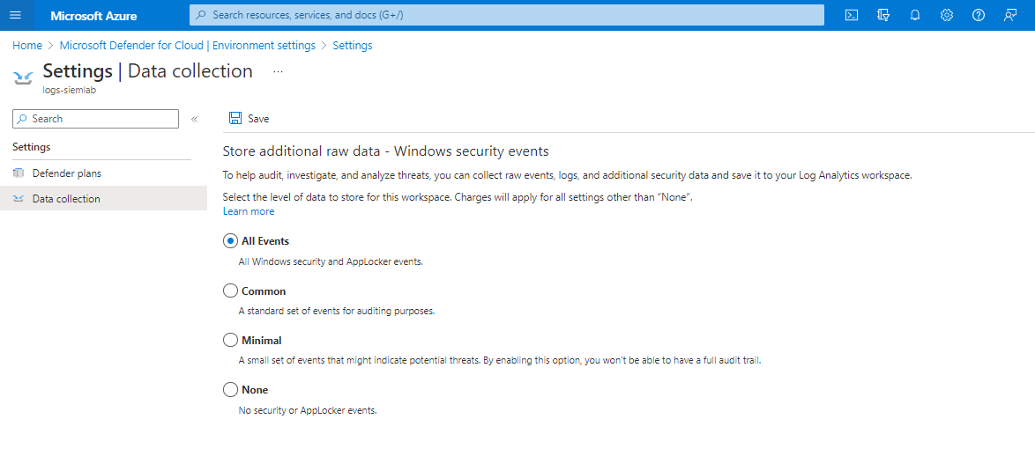

***Connect Log analytics to VM***

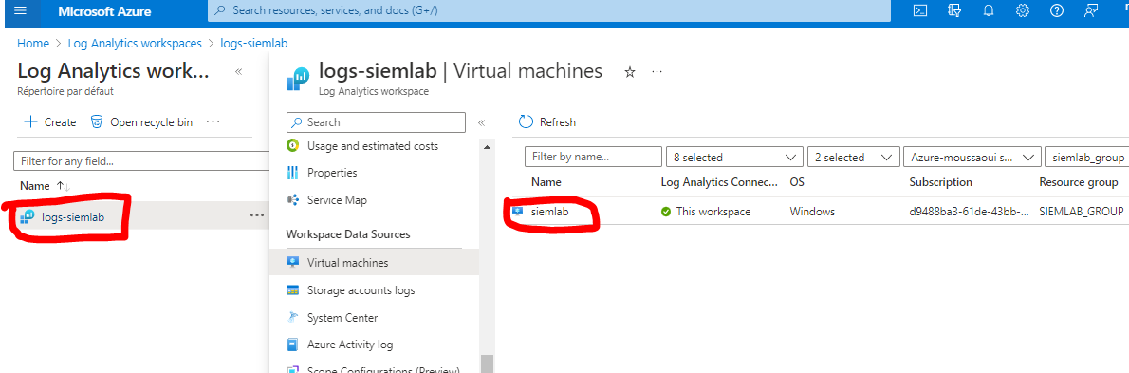

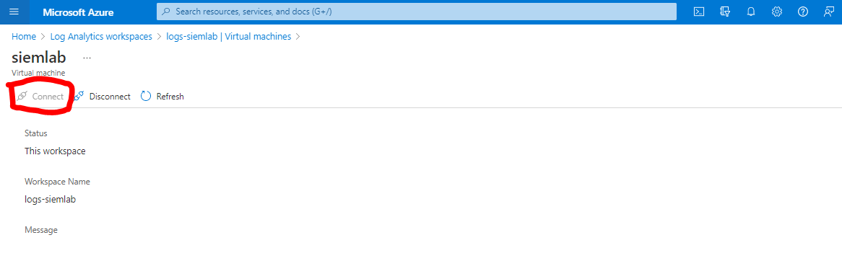

***Set up SIEM(Microsoft Sentinel) and connect it with log analytics***

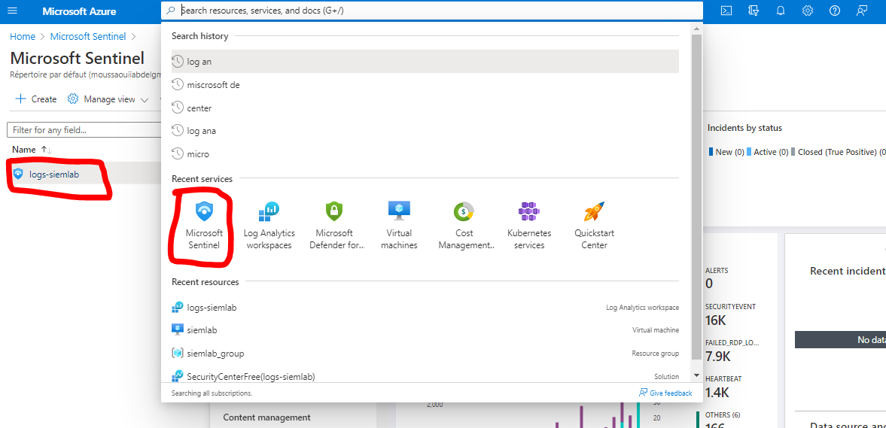

***Gather geodata for faild rdp login***

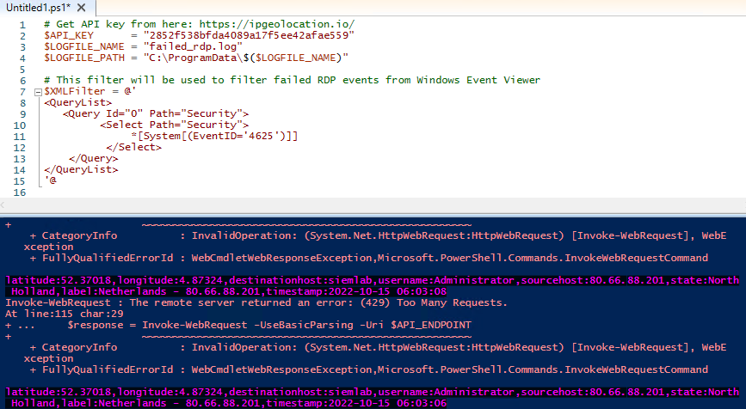

***Create customized log***

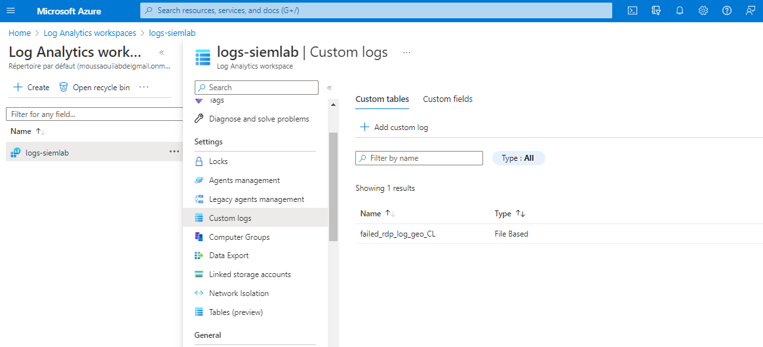

***Create custom fields***

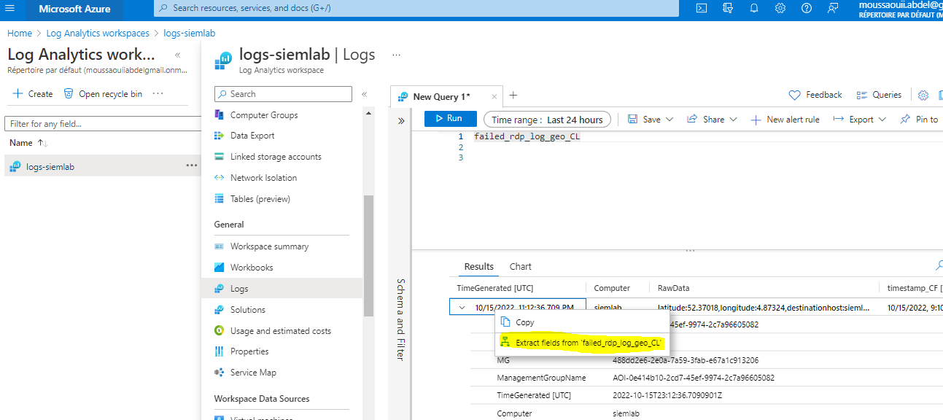

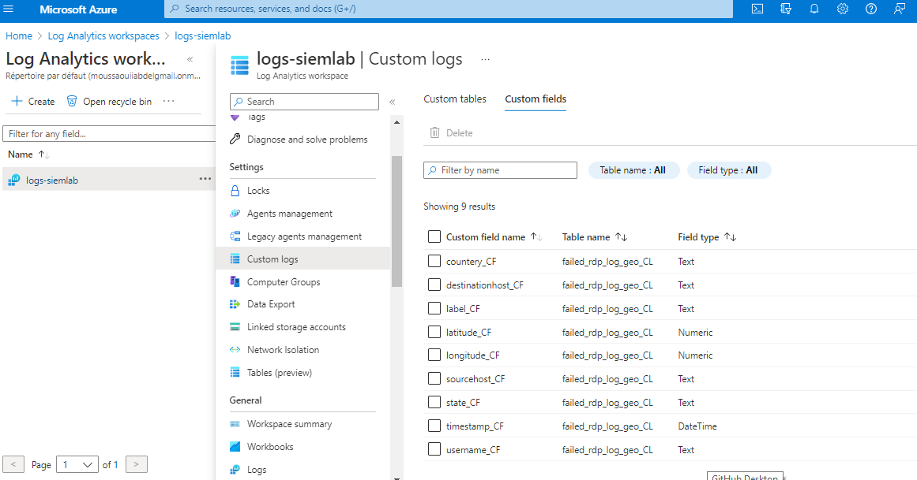

***Set up map in sentinel***

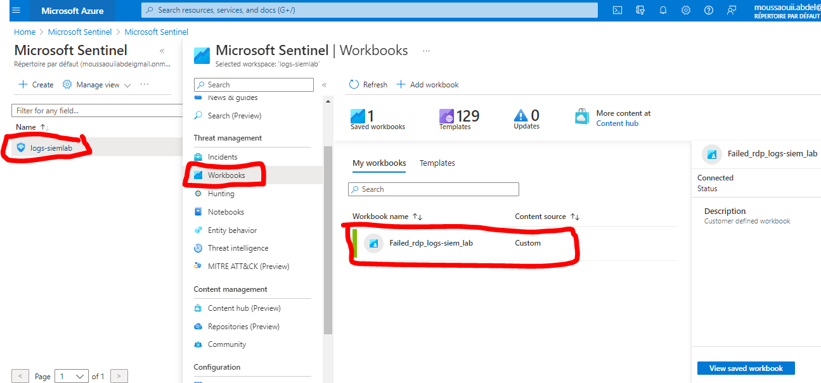

* Used query

failed_rdp_log_geo_CL | summarize event_count=count () by sourcehost_CF,latitude_CF,longitude_CF,

countery_CF, label_CF, destinationhost_CF | where destinationhost_CF != "samplehost"

| where sourcehost_CF != ""

Result

